**INTRODUCTION**

**Rationale of the Study**

Paint Center Sales and Inventory System is a system that can manage all information about paint, price, stock availability, transaction records, supplier records like name of the supplier it also maintains purchase and sales details so that we can search records quickly.

This system is intended for Chrisken Paint Center. There should be a proper mechanism to manage their day to day activities, which has been handled with partly manual and systematic work currently which will be inefficient time wasting. As a solution we can get an aid from information

technology. Sales & inventory management system is we proposed to reduce these

problems and will increase the competency and efficiency of their work. These are the following problems that paint center is usually experiencing: (1) Manual checking makes the personnel having difficulty to track products availability. (2) Manual sales and inventory computation are less reliable and can result in errors. (3) Because of written records it is sometimes difficult for personnel to keep the old records. (4) The personnel provide a receipt sheet written on paper, which takes a long time because they must fill out information and write payment for the customer. (5) The personnel consume a lot of time in paper works that makes the data processed slowly that makes it very time consuming. The purpose of the Paint Center Sales and Inventory System to manage the resources of the stocks efficiently, to reduce the losses incurred due to wrong entries. With the help of the Paint Center Sales and Inventory System, it will save time doing stock in, inventory and sales, it provides more easy ways to store information and data without hassles.

The system needs to be used to lessen the workload of the personnel and cashier of the paint center company to monitor the stock availability and sales information of the products accurately to prevent miscalculations.

Paint Center Sales and Inventory System will provide fast and reliable service in keeping the information and records of sales and inventory. Using this system will give much accuracy in managing the paint. It will give more exact details to be accurate. More secure and most efficient, where gathered information about the customer and can easily store and kept.

**Area of Investigation**

**Chrisken Paint Center**

**Functions of the proposed system**

Paint Center Sales and Inventory System will be developed to make the stock in, transaction and inventory easier and store inventory records, sales records and transaction records faster and accurate.

**Objectives of the Study**

**General Objectives**

The Researchers aim to study and develop a Sales and Inventory System at Chrisken Paint Center.

**Specific Objectives**

* To be able to create a system that will easily track product's availability
* To be able to design a system that will compute sales and inventory records accurately
* To be able to create a system that will keep the records for future needs.
* To be able to create a system that will provides printed receipts.
* To be able to create a system that will convert the sales and inventory procedure into a digital method, to lessen paper works.

**Scope and limitation of the study  
Scope of the Study**

The scope of the system focuses only on the Sales and Inventory System on Chrisken Paint Center this system provides offline use, stock in, inventory, sales and automatically prints transaction results and accurately calculates the results of overall total.

**Features of the proposed system**

For Paint Center Sales and Inventory System:

* Provide tracking product's
* Compute records accurately
* Keep records
* Generate printed receipt.
* Lessen paper works.

**Limitation of the study**

The proposed system is design only offline use and does not have an Android Platform nor IOS platform. It can only be access through PC and laptops.

**Significance of the Study**

This study intends to benefits not only the users but also the establishments that will use the system. The proposed system makes the easy work, less paper, fast and reliable, decreased the time consumed in processing results and it is user friendly. This study will hope to benefit the following:

**Paint Center Office/Personnel**

This system will help them lessen their paper works since they are responsible for handling transactions and inventory.

**Researchers**

Researchers can use their skills and knowledge in research. It is an opportunity for the researchers to put practice on what they have learned as Information Technology students.

**Future Researchers**

This system would be a great help for the future researchers. The documentation and system will serve as their literature or prior art and the system can be upgraded based on the new requirement.

**Flow of the Study**

**Input Process Output**

* Track product availability
* Records sales and inventory accurately
* Stored sales and inventory record
* Generate printed receipts
* Generated printed reports
* Check product availability
* Compute sales and inventory
* Check sales and inventory record
* View order
* Stored sales and inventory record
* Input data

* Input sales and inventory
* Input sales and inventory data
* Add order
* Input sales and inventory record

*Figure 1.0 Paint Center Sales and Inventory System Flow of the Study.*

**Functional Decomposition Diagram**

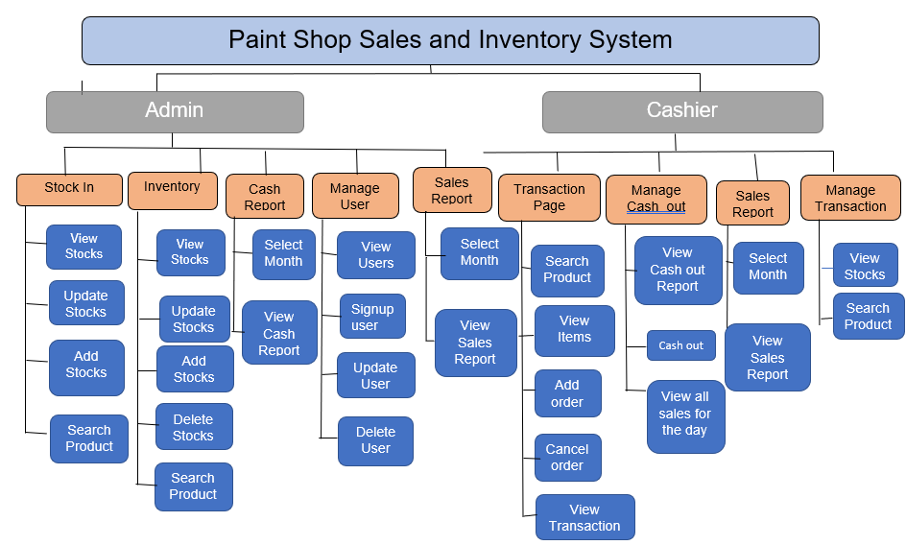

*Figure 1.1 Paint Center Sales and Inventory System Functional Decomposition Diagram.*

*.*

**System design**

**User Interface Design**

**Admin Menu Page**

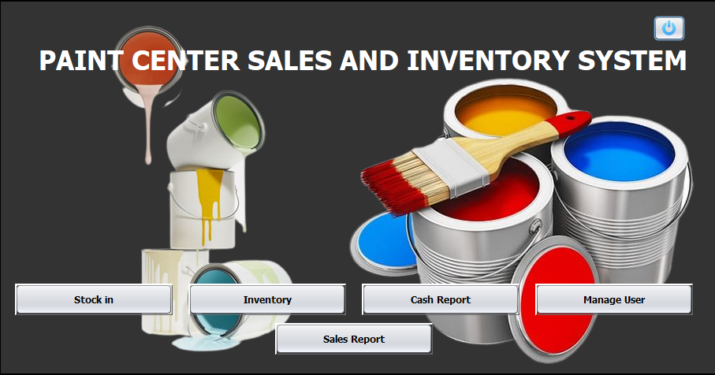

Buttons.

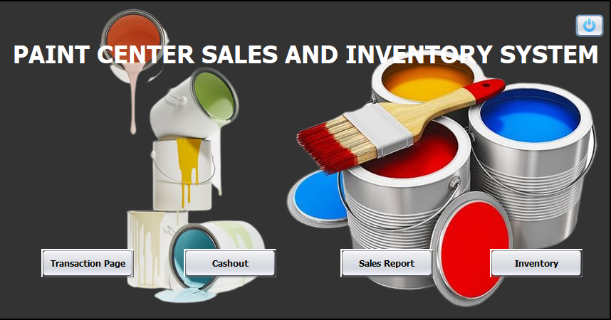**Cashier Menu Page**

Buttons

**Screen Loading Page**



**Login Page**

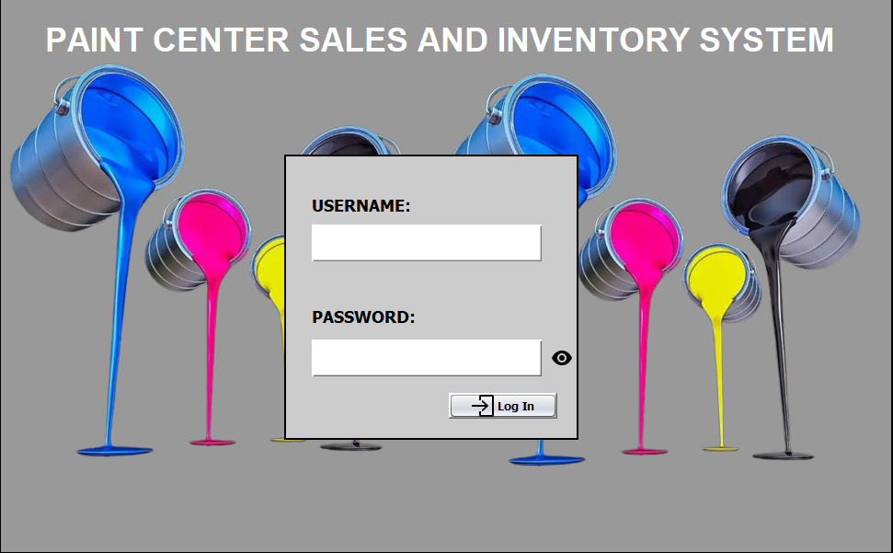

Log in button that directs to the admin or cashier.

Password of the user.

Username of the user.

**Admin Panel**

Search button to search stocks

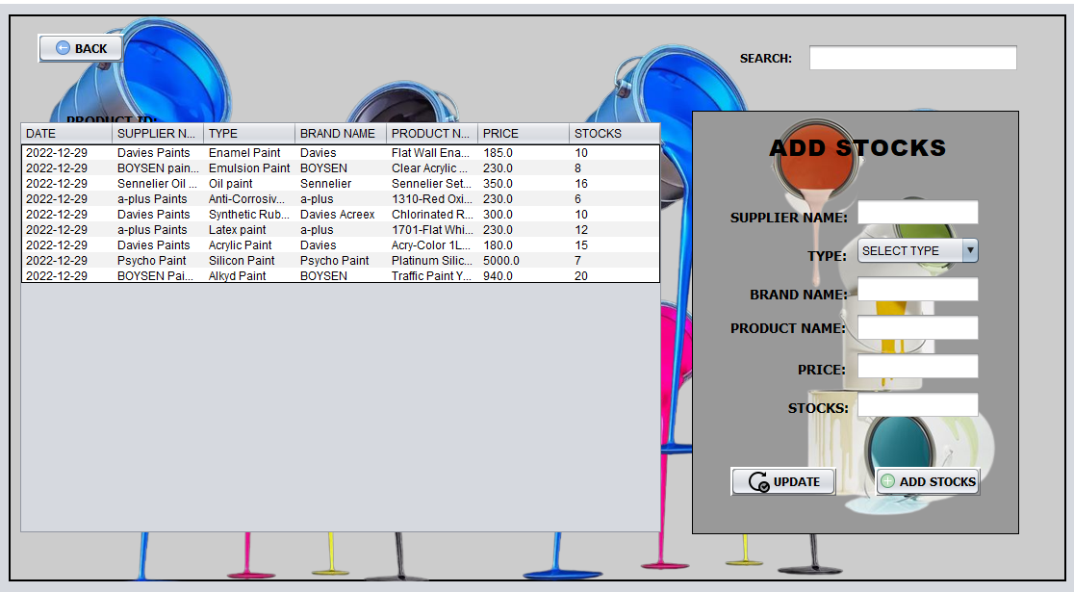**Stock In**

Update button to update stocks

Back Button

Product details

Add button to add stocks

**Admin Inventory**

Search button to search stocks

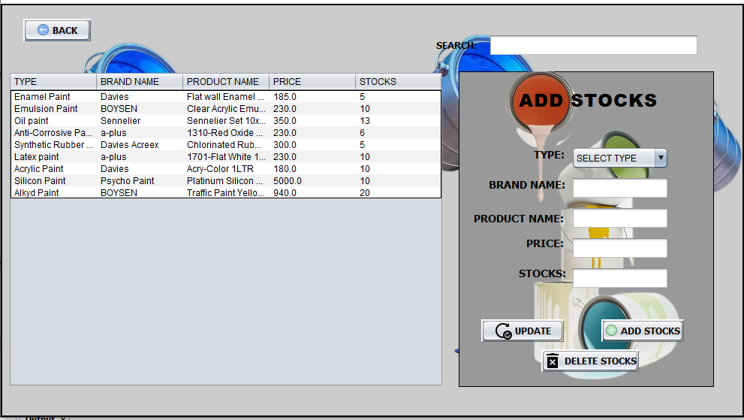

Product details

Product’s Stocks

Back button

Add button to add stocks

Delete button to delete stocks

Update button to update stocks

**Manage User Page**

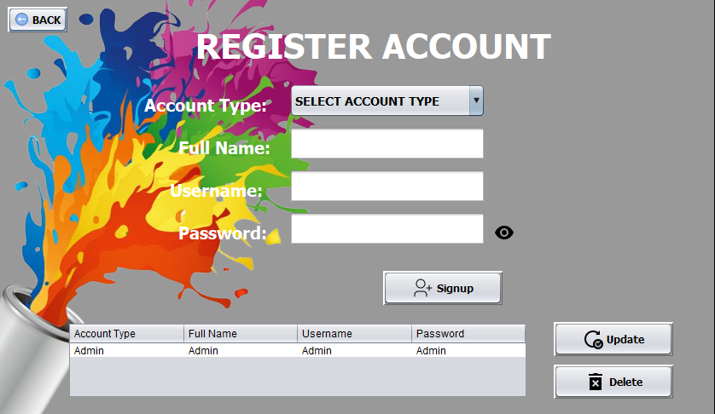

Button to signup user’s

Delete button to delete user’s data

Update button to update user’s data

Back Button

User’s Data

**Cashier Panel**

**Transaction Page**

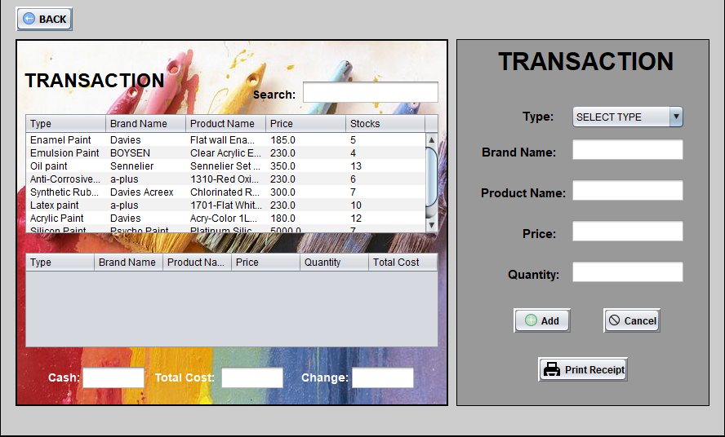

Product details

To input cash

Transaction table

Available product stocks

Total cost of product ordered

Back button

Print button will print the transaction receipt

button to cancel order

button to add order

**Cash out**

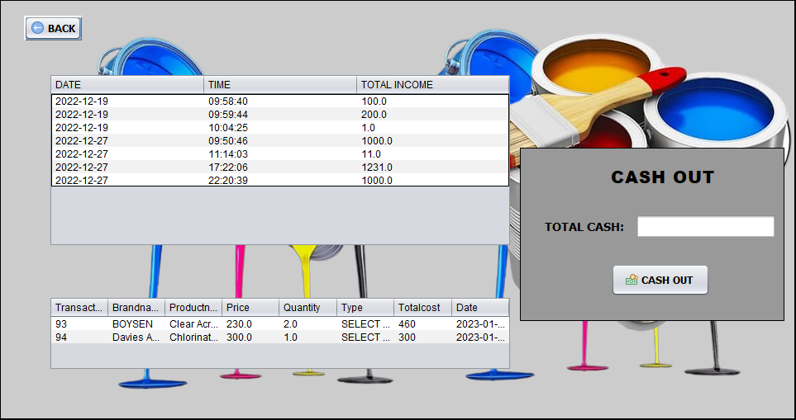

Cash out table

Button to cash out cashier

All products sold for the day

Back button

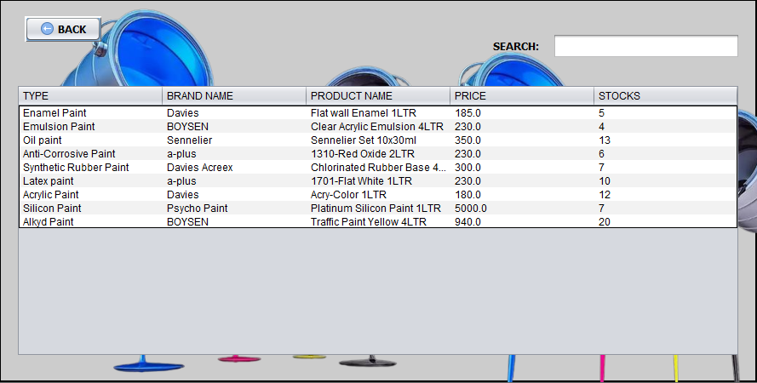**Cashier Inventory**

Search available products

Back Button

Available product table

**Reports**

**Cash Reports**

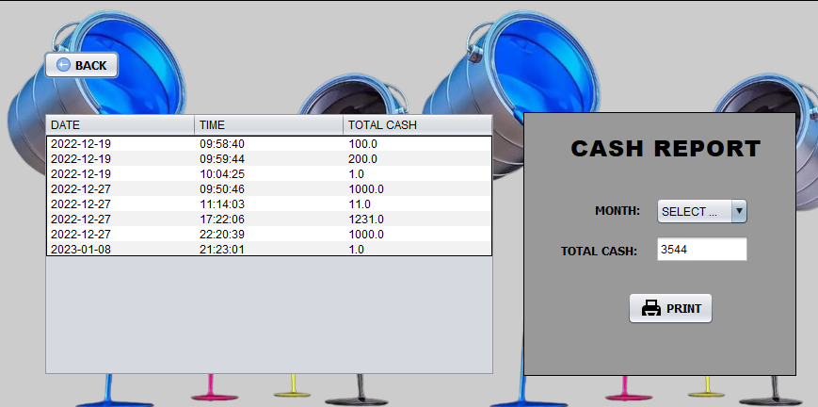

Cash reports table

Back button

Print button that will print the cash report

**Admin Sales Reports**

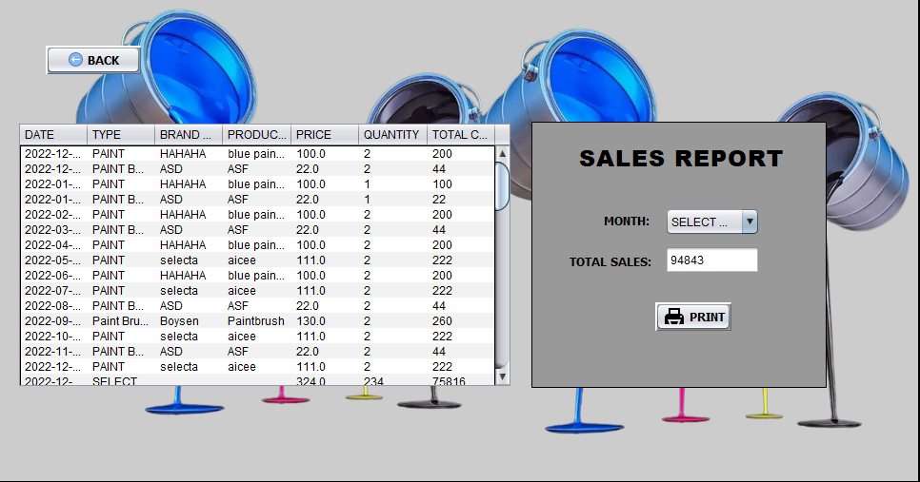

Back button

Sales report table

Print button will print the sales report

**Cashier Sales Reports**



Back Button

All products sold

Button to print sales report

**Definition of Terms**

* **Paint** – a substance composed of solid coloring matter suspended in a liquid medium and applied as a protective or decorative coating to various surfaces, or to canvas or other materials in producing a work of art..
* **Transaction** – A transaction is a completed agreement between a buyer and a seller to exchange goods, services, or financial assets in return for money.
* **Sales** – refers to a company's revenue earned from the sales of products or services
* **Paint Center Sales and Inventory System** - is an offline system that can manage all information about paint, price, stock availability, transaction records, supplier records like name of the supplier it also maintains purchase and sales details so that we can search records quickly.

**Database Design**

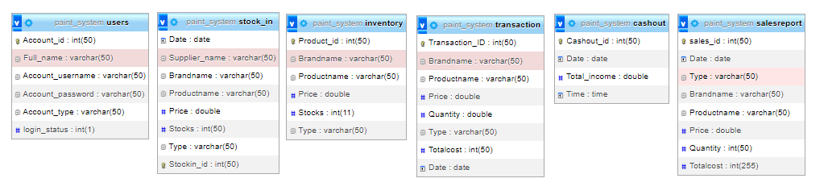

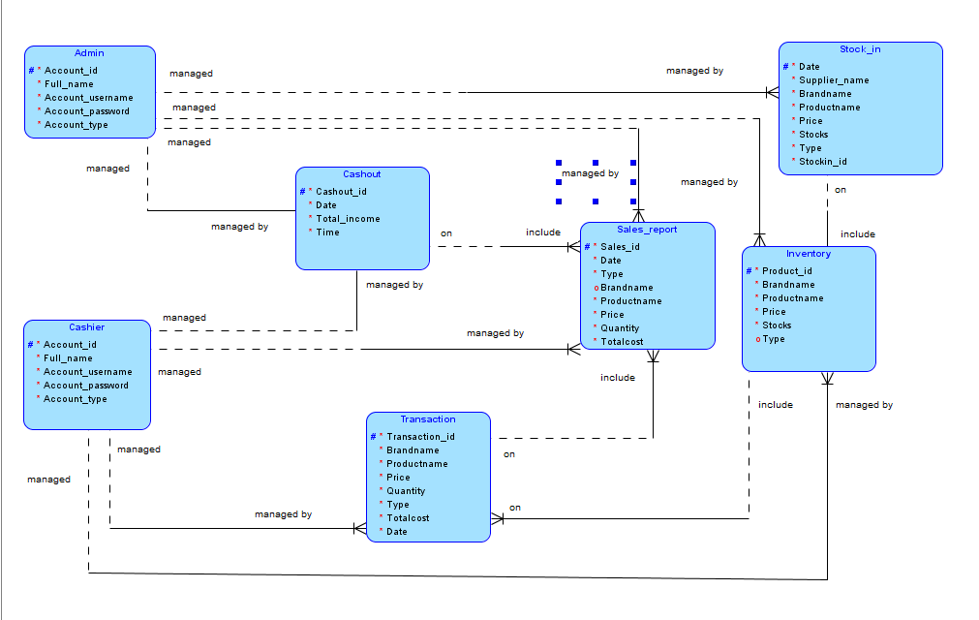**Entity Relationship Diagram**

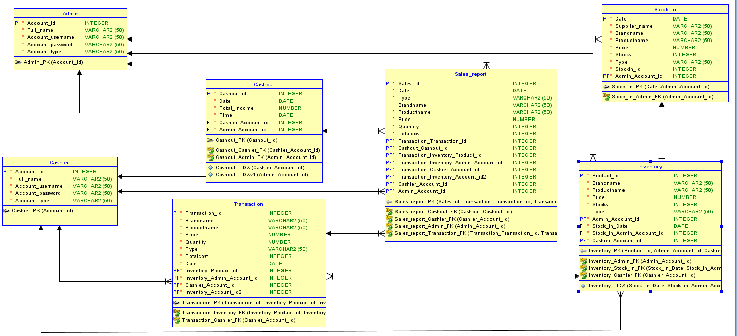**Relational Database**

**Data Dictionary**

|  |  |  |  |  |
| --- | --- | --- | --- | --- |
| **Table name** | **users** | | | |
| **Attribute** | **Type** | **Null** | **Default** | **Description** |
| Account_id | int(50) | No | PK | Indicates the ID of the user |
| Full_name | varchar(50) | No |  | Indicates the Full name of the user |
| Account_username | varchar(50) | No |  | Username of the user |
| Account_password | varchar(50) | No |  | Password of the user |
| User_type | varchar(50) | No |  | User type indicates what admin selected |

*Table 1.1 Data Dictionary of users table of the Paint Center Sales and Inventory System*

|  |  |  |  |  |
| --- | --- | --- | --- | --- |
| **Table name** | **Stock_in** | | | |
| **Attribute** | **Type** | **Null** | **Default** | **Description** |
| Stockin_id | Int(50) | No | PK | Indicates the ID of the product |
| Date | date | No | current_timestamp() | Indicates the date of the stock in products |
| Supplier_name | varchar(50) | No |  | Indicates the supplier name of the products |
| Brandname | varchar(50) | No |  | Indicates the brand name of the products |
| Productname | varchar(50) | No |  | Indicates the name of the product |
| Price | double | No |  | Indicates the price of the products |
| Stocks | int(50) | No |  | Indicates the stocks of the products |
| Type | varchar(50) | No |  | Indicates the type of the stock in products |

*Table 1.2 Data Dictionary of stock_in table of the Paint Center Sales and Inventory System*

|  |  |  |  |  |
| --- | --- | --- | --- | --- |
| **Table name** | **inventory** | | | |
| **Attribute** | **Type** | **Null** | **Default** | **Description** |
| Product_id | int(50) | No | PK | Indicates the product id of the product inventory |
| Brandname | varchar(50) | No |  | Indicates the brand name of the product |
| Productname | varchar(50) | No |  | Indicates the name of the product |
| Price | double | No |  | Indicates the price of the product |
| Stocks | int(50) | No |  | Indicates the stocks of the product |
| Type | varchar(50) | No |  | Indicates the type of the product |

*Table 1.3 Data Dictionary of inventory table of the Paint Center Sales and Inventory System*

|  |  |  |  |  |
| --- | --- | --- | --- | --- |
| **Table name** | **transaction** | | | |
| **Attribute** | **Type** | **Null** | **Default** | **Description** |
| Transaction_ID | int(50) | No | PK | Indicates the ID of the transaction |
| Brandname | varchar(50) | No |  | Indicates the Brand Name of the product |
| Productname | varchar(50) | No |  | Indicates the name of the product |
| Price | double | No |  | Indicates price of the product |
| Quantity | double | No |  | Indicates the quantity of the product |
| Type | varchar(50) | No |  | Indicates the type of the product |
| Totalcost | Int(50) | No |  | Indicates the total cost of the ordered products |
| Date | date | No | current_timestamp() | Indicates the date of the transaction |

*Table 1.4 Data Dictionary of transaction table of the Paint Center Sales and Inventory System*

|  |  |  |  |  |
| --- | --- | --- | --- | --- |
| **Table name** | **cashout** | | | |
| **Attribute** | **Type** | **Null** | **Default** | **Description** |
| Cashout_id | int(50) | No | PK | Indicates the ID of the cashier’s cashout |
| Date | date | No | current_timestamp() | Indicates the date of the cashier’s cashout |
| Total_income | double | No |  | Indicates the total income of the products sold |
| Time | time | No | current_timestamp() | Indicates the time of cashier’s cashout |

*Table 1.5 Data Dictionary of cashout table of the Paint Center Sales and Inventory System*

|  |  |  |  |  |  |
| --- | --- | --- | --- | --- | --- |
| **Table name** | **salesreport** | | | | |
| **Attribute** | **Type** | **Null** | **Default** | **Description** |
| sales_id | int(50) | No | PK | Indicates the ID of the sales report |
| Date | date | No | current_timestamp() | Indicates the date of the sales report |
| Type | varchar(50) | No |  | Indicates the type of the product |
| Brandname | varchar(50) | No |  | Indicates the brand name of the product |
| Productname | varchar(50) | No |  | Indicates the product name of the product |
| Price | double | No |  | Indicates the price of the products |
| Quantity | int(50) | No |  | Indicates quantity of the product |
| Totalcost | int(255) | No |  | Indicates the total cost of the products sold |

*Table 1.6 Data Dictionary of sales report table of the Paint Center Sales and Inventory System*

**References**

Retrieve from: https://www.dictionary.com/browse/paint

Retrieve from: <https://www.sumup.com/en-gb/invoices/dictionary/sales/>

Retrieve from: <https://www.investopedia.com/terms/t/transaction.asp>

*(2017, 08). Inventory System of De Castrence Paint Center and Construction Supplies. OtherPapers.com. Retrieved 01, 2023, from* [*https://www.otherpapers.com/essay/Inventory-System-of-De-Castrence-Paint-Center-and/61539.html*](https://www.otherpapers.com/essay/Inventory-System-of-De-Castrence-Paint-Center-and/61539.html)

*(2017, 11) Sales & Inventory Management System For Mahanama Paint Center (PVT) LTD Retrieved 01, 2023, from* [*https://dl.ucsc.cmb.ac.lk/jspui/bitstream/123456789/4080/1/1415425.pdf*](https://dl.ucsc.cmb.ac.lk/jspui/bitstream/123456789/4080/1/1415425.pdf)